How to – Enter (Type) Hands into aaBridge

Compiled by Roger Pfister http://RogerPf.com/aaBridge roger@RogerPf.com

- You have a bridge hand on paper or in some format that might as well be paper (like in a .pdf file) and you want to get these hands into aaBridge. (Perhaps later get them up to BBO).
- With your Simple Editor (Notepad++ Windows or TextWrangler Mac see the final section as to how to get and install them.) create a file e.g. myDeals.lin that end in '.lin'
HINT To show file name extensions (.lin) on your computer see the links section at the end.
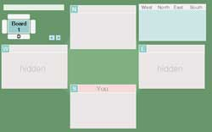
- In add (type-in) just the 4 characters md||
those two vertical lines are the 'bar' character.
- Drag & Drop myDeals.lin on to an open aaBridge window.
The empty deal will now show, see image.
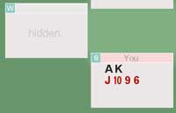
- Start to add in the cards.
First the South, then West then North
The hands are separated by commas ',' and the suits by spaces in SHDC order. At this stage do NOT add any suit characters (SHDC). Add in '10' as 't', void as '-'.
For example, type so the line now reads md|ak jt96| and do a
File Save (Ctrl S is the Notepad++ shortcut).
The aaBridge window will change and show as (see image).
HINT Set Menubar > Options > Show > (right hand column) Point Count check box to ON.
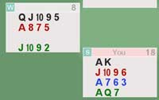
- Keep adding cards and saving – when you have all 13 cards that hand's Point Count will show. So
md|ak jt96 a763 aq7, qjt95 a875 - jt92|
and a File Save will show as (see image).
- When you have completed 3 full hands aaBridge will fill in the 4th hand for you (not shown).

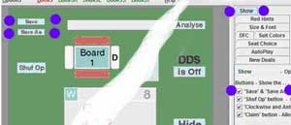
HINT Set Menubar > Options > Show >
(right hand column) Save File check box to ON.

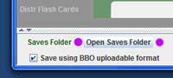
HINT You can open the saves folder by clicking the
Open Saves folder button as shown.

- When you have all four hands looking correct you can save within aaBridge to a temp file. I suggest you use the name xxx.lin (not shown).
- Open the new xxx.lin file in your simple text editor it will look something like this
qx|o1|rh||ah|Board 1 |md|1SAKHJT96DA73CAQ7, . . . ,S876H2DJT952CK864|sv|O|sk||pg| |
(Note The West and North hands have been omitted to make it fit on the one line above.)
- Copy ALL the contents from the file xxx.lin and add it to your myDeals.lin
when doing so REPLACE ALL of the line you have just typed in.
If you want to upload the Deal to BBO IT MUST ALL BE ON ONE LINE.
- To change the Board number change BOTH green '1's to the same number.
- To change the Dealer change the red '1' to be 1=>South 2=>West 3=>North 4=>East
- To change the Vulnerability change the red 'O' to be O=>None N=>NS E=>EW B=>Both
- You can build up multiple deals in your myDeals.lin file
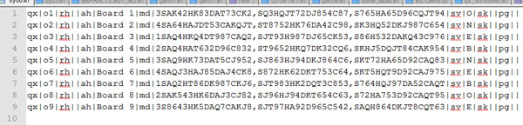

- As you add each deal (no just one line) you will see that Deal's 'bobble' apear on the Navbar


- You are done your myDeals.lin lin file can be uploaded to BBO if you wish.
Use the standard methods supplied by BBO to upload linfiles. (see below)

Notes on the BBO lin file format
(that aaBridge uses when saving lin files for BBO upload)
qx|o1|rh||ah|Board 1|md|3SxxxHxxxDxxxCxxx,SHDC,SHDC|sv|O|sk||pg||
The cards are part of the 'md|' command and follow the dealer. You must supply at least three full hands. The first hand given is SOUTH, next is WEST, NORTH, EAST. It is common to leave out the fourth hand. The cards positions for the South hand are shown above as red x's. Card values must be one of
AKQJT(not 10)98765432. The suit symbols and card values must be in CAPITALS. (Did I say BBO was fussy). Note there are commas ',' separating the HANDS.

How to get - aaBridge Hands up to BBO

This is covered in a Blog post please see
http://musingsonbridge.rogerpf.com/2015/12/how-do-i-get-aabridge-hands-up-to-bbo.html

How to get - Hands on BBO in to aaBridge

This is covered in a Blog post please see
http://musingsonbridge.rogerpf.com/2015/11/how-do-i-get-bbo-hand-into-aabridge.html

<end of page>

Editors and Other Hints

A good FREE simple editor for Windows is
notepad++ from https://notepad-plus-plus.org/

A good FREE simple editor for MAC is

TextWrangler from http://www.barebones.com/products/textwrangler/download.html

(or look in the MAC Store for TextWrangler)

How to show file extensions e.g .lin on your computer

for Windows see

http://windows.microsoft.com/en-us/windows/show-hide-file-name-extensions

for MAC see

https://support.apple.com/kb/PH19072?locale=en_US

<end of document>

